Tutorial problems 2

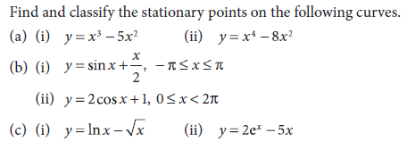

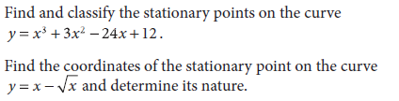



Find the intervals of increasing, decreasing and concavity, stationary and inflection points of the function $f\left(x\right)=x^{3}+x^{2}-8x-12$. Sketch the graph of this function.

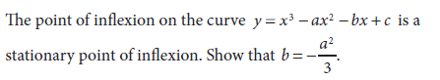

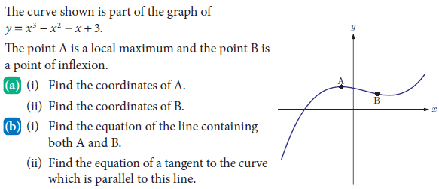

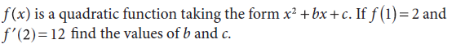

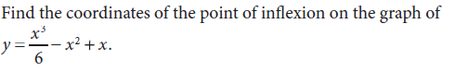

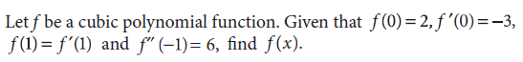

Locate and describe the stationary points of the function $f\left(x\right)=x^{4}-8x^{2}$.